*Florida International University*

*School of Computing and Information Sciences*

Software Engineering Focus

Feature Document

User Story ID #647

**Name:** Mario Fidalgo

**Team Member(s):** Kyle Ryan

**Project:** Mobile Judge 9.0

**Product Owner(s)**: Masoud Sadjadi

**Mentor(s)**: Masoud Sadjadi

**Instructor**: Masoud Sadjadi

**User Story Name: Allow Students Fields to be Edited**

* Description: As an admin, I want to be able to edit the fields for a given student’s profile so that I can modify a student’s information to their current information.

Acceptance Criteria

* When I select the update button all the fields in the selected row become editable.
* After my changes the update button should accept the new changes in the fields.
* After my changes the cancel button should disregard the new changes in the fields.
* PID and Email fields should be verified as valid before being accepted.

**Use Case**

* Name: Edit Students Fields
* Actor: Admin
* Preconditions: User must be logged in as an admin and in the people view.
* Description <Flow of events>:

1. User double clicks on desired student they wish to edit.

2. System makes fields editable.

3. User modifies the fields they wish to make changes to & clicks update.

4. System updates fields in the database.

**Use Case Diagram**

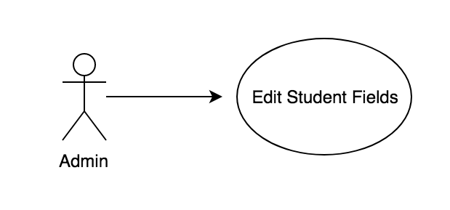

**Sequence Diagram**

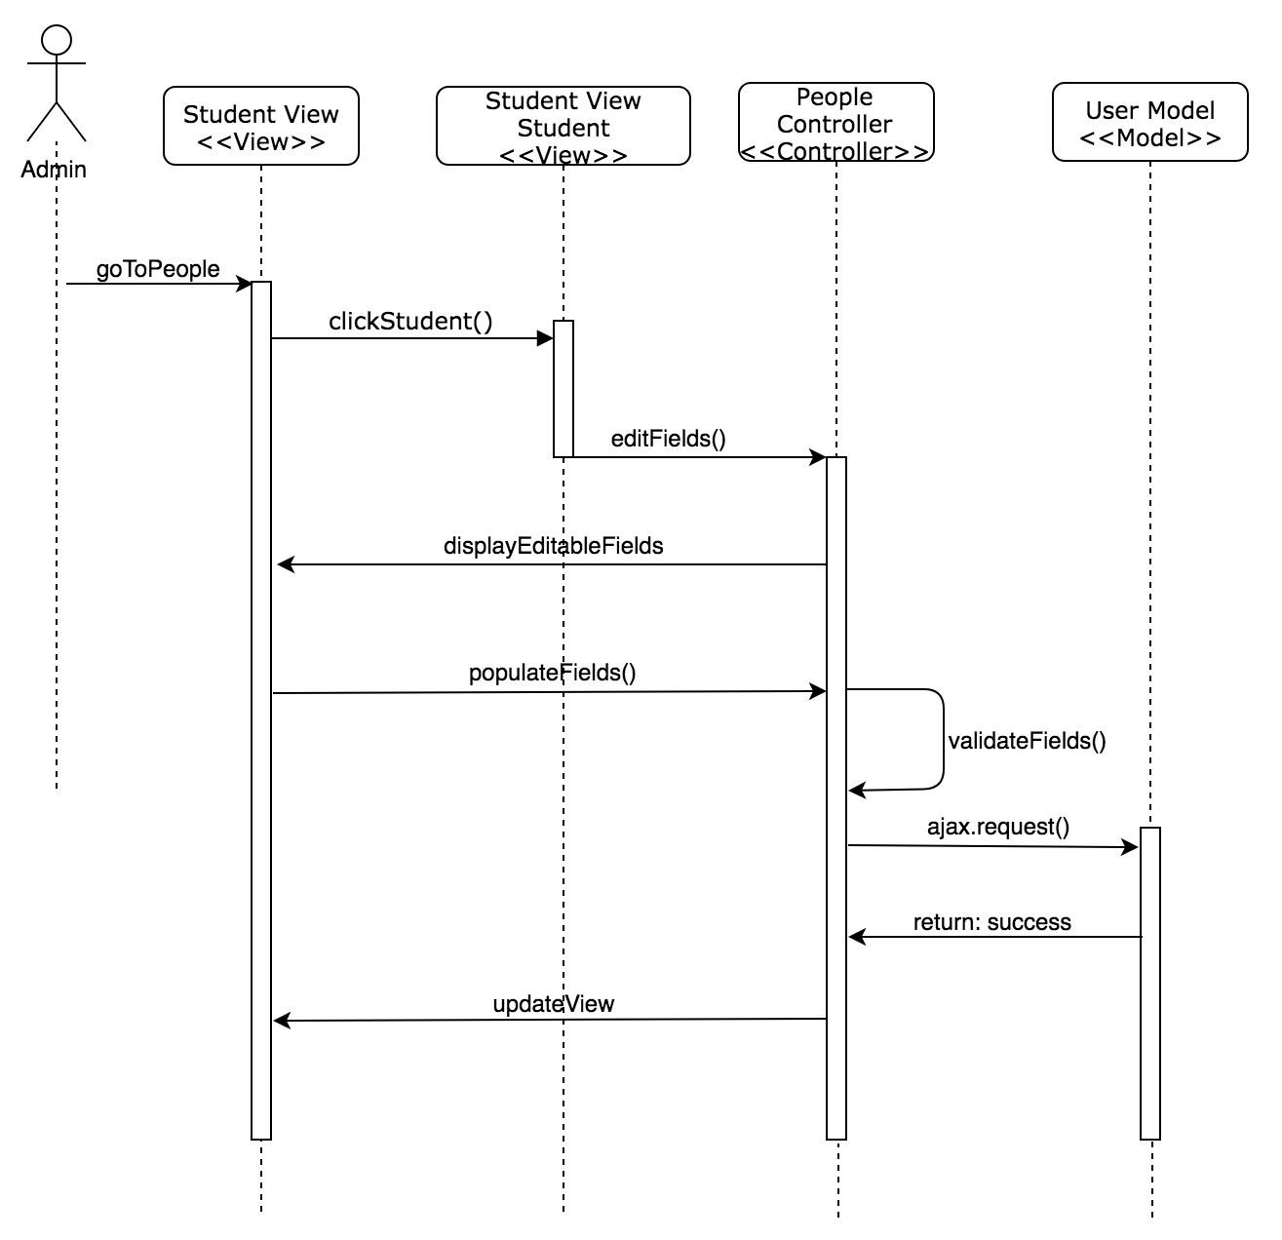

**Class Diagram**

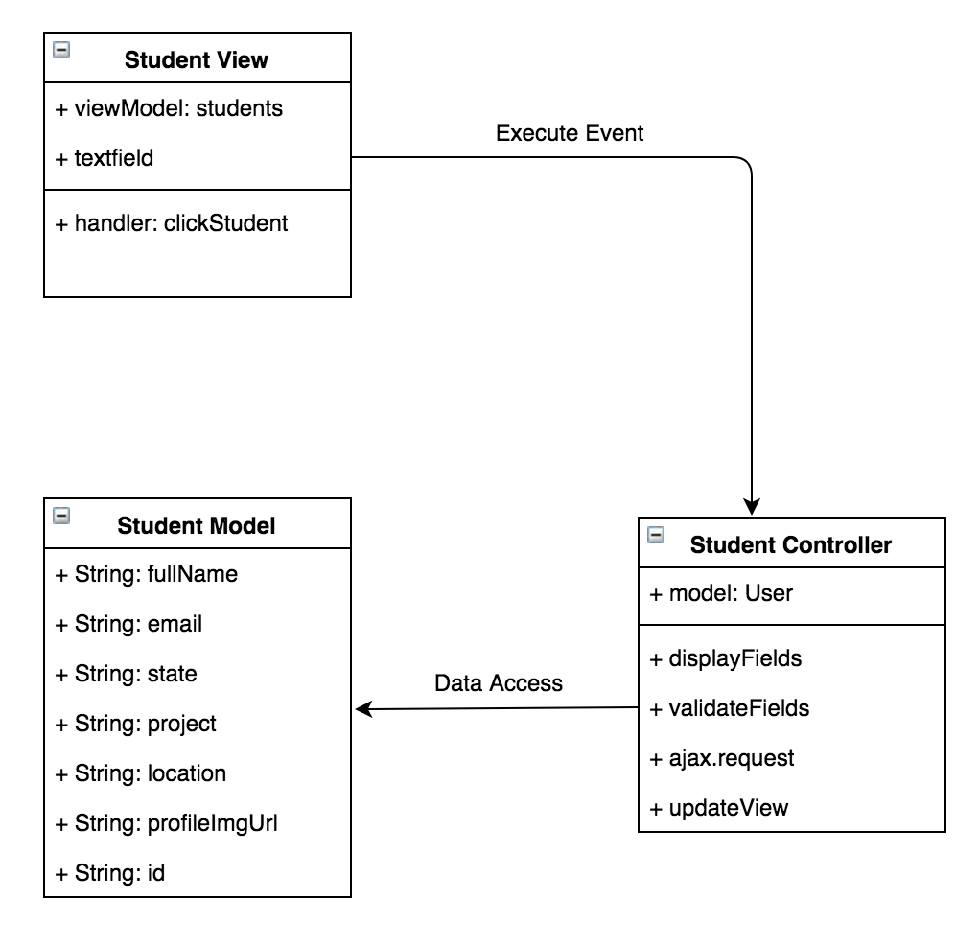

**Unit Test & Integration Test**

**Test case ID:** MJ-647-01

**Description/Summary of Test:** Modifying Student’s Name Only

**Precondition:** Admin is logged in and currently viewing the students tab found in people side tab.

**Expected Results:** Student’s name only gets modified and updated.

**Actual Result:** Student’s name only got modified and updated.

**Status (Fail/Pass):** Pass

**Test case ID:** MJ-647-02

**Description/Summary of Test:** Modifying Student’s Email Only

**Precondition:**Admin is logged in and currently viewing the students tab found in people side tab.

**Expected Results:** Student’s Email only gets modified and updated.

**Actual Result:** Student’s Email only got modified and updated.

**Status (Fail/Pass):** Pass

**Test case ID:** MJ-647-03

**Description/Summary of Test:** Modifying Student’s Project Only

**Precondition:**Admin is logged in and currently viewing the students tab found in people side tab.

**Expected Results:** Student’s Project only gets modified and updated.

**Actual Result:** Student’s Project only got modified and updated.

**Status (Fail/Pass):** Pass

**Test case ID:** MJ-647-04

**Description/Summary of Test:** Modifying Student’s Location Only

**Precondition:**Admin is logged in and currently viewing the students tab found in people side tab.

**Expected Results:** Student’s Location only gets modified and updated.

**Actual Result:** Student’s Location only got modified and updated.

**Status (Fail/Pass):** Pass

**Test case ID:** MJ-647-05

**Description/Summary of Test:** Modifying Student’s State Only

**Precondition:**Admin is logged in and currently viewing the students tab found in people side tab.

**Expected Results:** Student’s State only gets modified and updated.

**Actual Result:** Student’s State only got modified and updated.

**Status (Fail/Pass):** Pass

**Test case ID:** MJ-647-06

**Description/Summary of Test:** Modifying Multiple Student’s Fields

**Precondition:**Admin is logged in and currently viewing the students tab found in people side tab.

**Expected Results:** All selected fields get modified and updated.

**Actual Result:** All selected fields got modified and updated.

**Status (Fail/Pass):** Pass

**Test case ID:** MJ-647-07

**Description/Summary of Test:** Modifying All Student’s Fields

**Precondition:**Admin is logged in and currently viewing the students tab found in people side tab.

**Expected Results:** All selected fields get modified and updated.

**Actual Result:** All selected fields got modified and updated.

**Status (Fail/Pass):** Pass

**Test case ID:** MJ-647-08

**Description/Summary of Test:** Cancel modification of Student’s record

**Precondition:** Admin is logged in and currently viewing the students tab found in people side tab.

**Expected Results:** Modified fields get reverted back to original information.

**Actual Result:** Modified fields got reverted back to original information.

**Status (Fail/Pass):** Pass

**Test case ID:** MJ-647-09

**Description/Summary of Test:** Inputting invalid Email in Student Email Field

**Precondition:**Admin is logged in and currently viewing the students tab found in people side tab.

**Expected Results:** Admin gets message saying “This field should be an email address in the format “[user@example.com](mailto:user@example.com)” and does not allow the record to be updated.

**Actual Result:** Admin got message saying “This field should be an email address in the format “[user@example.com](mailto:user@example.com)” and does not allow the record to be updated.

**Status (Fail/Pass):** Pass

**Visual User Guide**

